Project Awesome

Main Menu Document

**Table of Contents**

1 Introduction 3

2 Design Goals 3

3 System Behavior 3

4 Logical View 4

4.1 High-Level Design ……………………………………………………………… 4

**4.2 Mid-Level Design** ……………………………………………………………..... **4**

4.3 Layout Design of Main Menu …………….. ………………………………….. 5

4.4 Used Case of Main Menu …………….. ………………...…………………….. 5

Change History

**Version:** <0.1>

**Modifier:** <Scott Kennedy>

**Date:** 14/03/2021

**Description of Change:** First Edition for Alpha 1

**Version:** <0.2>

**Modifier:** <Brandon Coates>

**Date:** 12/04/2021

**Description of Change:** Implemented Recommended Changes to Charts and Information

# Introduction

This document describes the architecture and design for Project Awesome being developed for Team Awesome. Project Awesome is a Single Player casual puzzle game.

The purpose of this document is to describe the architecture and design of the Main Menu.

# Design Goals

The design priorities for the game system are:

* The design should be highly open to iterations and changes, with the possibility to easily switch between menus and gameplay.

# System Behavior

The game is built with only a single level completed. The complexity of the system is causally related to the limited scope of the project. If there were more levels to be added, the menu should be able to remain unchanged but still capable of interacting with the new content.

# Logical View

## High-Level Design (Architecture of the Entire system)

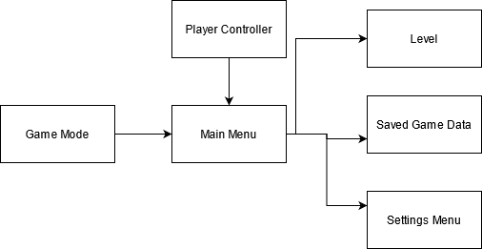

* Game Mode is the base of game
* Opens into the Main Menu
* Menu uses the Player Controller
* Menu splits up into 3 sub-sections

## Mid-Level Design

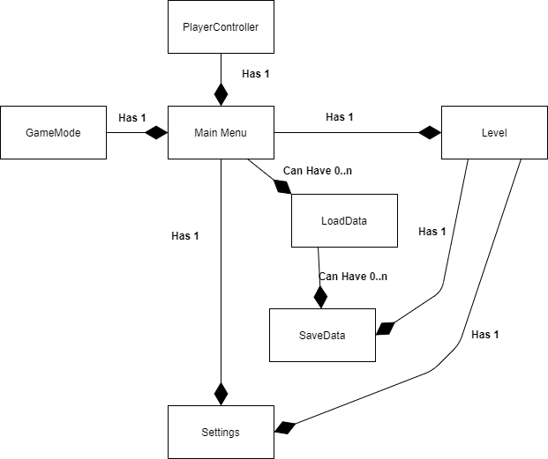

* The Main Menu is the players first interaction with the game.
* The player is given 4 options to select from: New Game, Load, Settings and Exit.
* While the menu is up all controls are locked to the menu.
* New Game will Launch the first level and give full control to the player
* Load will bring the player to a second menu with saved files, selecting one will launch that level.
* Settings will bring the player to a second menu with various options.
* Exit will quit the game.

## Layout Design of Main Menu

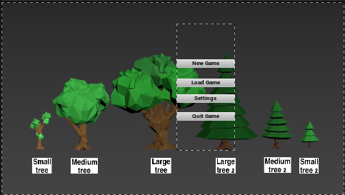

* Has a backdrop showcasing some of the art assets
* Center screen has a canvas that hold the 4 buttons

## Use Case of Main Menu

Clicking New Game:

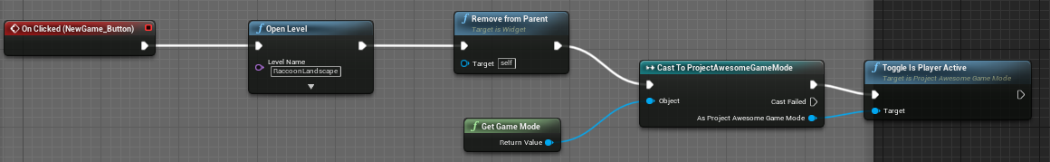

* Sends an OnClick event
* Opens the selected level -> Level 1
* Gets the GameMode and Casts to ProjectAwesomeGameMode
* Flips a bool to give full control to player

Clicking Setting (uncompleted version)

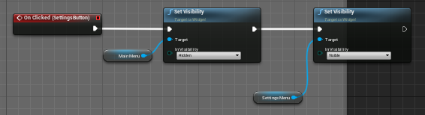

* Sends an OnClick event
* Sets the Visibility of Main Menu to Hidden
* Sets the Visibility of Setting to Visible

Settings Menu Back

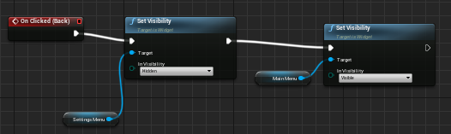

* Sends an OnClick event
* Sets the Visibility of Settings Menu to Hidden
* Sets the Visibility of Main Menu to Visible